**AIM:** Design NFA to accept any number of b’s where input={a,b}.

**INPUT:**

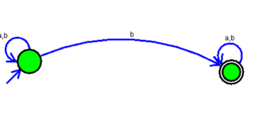

**OUTPUT:**

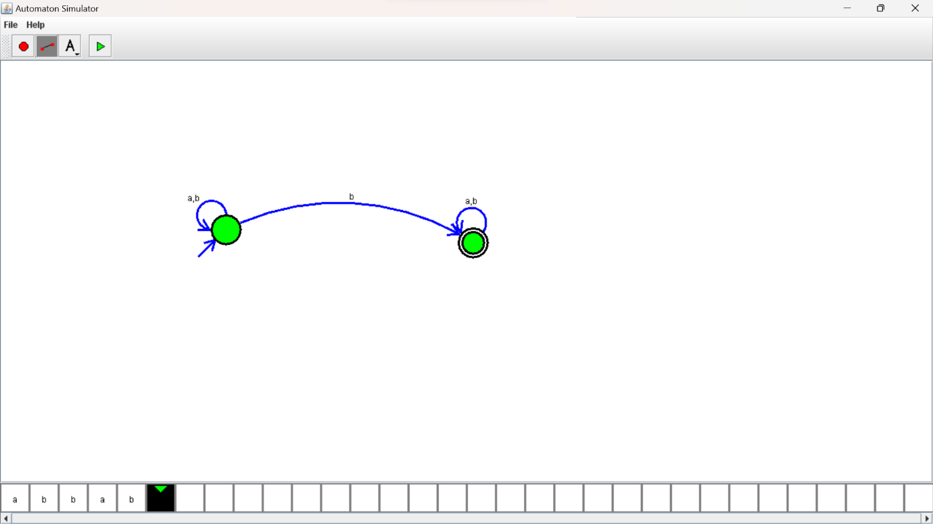

**RESULTS:**

NFA to accepting any number of b’s where input={a,b}.